Lo-Se-Ca Foundation
Health and Food Safety Course

Updated February 2015

- Food Service Supervisor

You become a Food Service Supervisor when you become a preparer of food. When you become the Food Service Supervisor you must follow its code of conduction.

Food Service Supervisors Code:

- The kitchen is completely clean and sanitary in areas where food is stored, prepared or served.
- All employees are clean, properly dressed, and free from cuts, abrasions and infections.
- Staff is adequately instructed in all matters relating to good sanitary practices in preparing and serving food.
- Hot foods are kept hot and cold foods are kept cold.
- Ready-to-eat foods are kept covered to protect them from contamination.
- Garbage is disposed of immediately and in an approved way.
- The home is rodent and insect free.

- Spread of Bacteria

Microbiology
Microbes are all around us, they are found in soil, water, dust, ice, air, plants, animals, insects, humans and even on other microbes. A few types are harmful and can produce diseases in man, plants and animals. These disease-causing microbes are called PATHOGENES.

Types of Microbes:
Bacteria
Viruses
Protozoa
Fungi

There are 6 conditions which support the growth, reproduction and survival or microbes:
- Food
- Acidity or PH
- Time
- Temperature
- Oxygen
- Moisture

Food:

Bacteria Microbes prefer food that has lots of protein. Such as milk, poultry and eggs. These foods are called potentially hazardous foods. These potentially hazardous foods actually encourage these bacteria to grow and also carry the bacteria to the person who's going to eat the food.

Acidity or PH:

pH is a measure of the acidity or alkalinity of a substance. Microbes prefer food that is closer to neutral (pH 7) or slightly acidic (pH 5-6)
Foods that are acidic, (pH levels below 4.6), won't allow this bacteria to grow. So foods like vinegar and fresh fruits (especially lemons and oranges and other foods like that), don't provide a good pH for bacteria to grow.
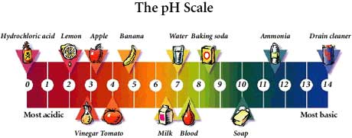

Time:

Growth of bacteria becomes very rapid given the right conditions. Cell division (binary fission) can happen every 20 minutes. One cell becomes 2. Then 2 become 4, then 4 become 8, then 8 become 16. So the longer this food hangs around, the longer this bacterium continues to grow. And the more bacteria there is in a food the more likely you're going to be effected if you eat it.
One bacterium in optimum or perfect conditions will multiply to over 2 million in a 7 hour period

Temperature:

Most pathogens can rapidly reproduce at temperatures ranging from 4 degrees Celsius to 60 degrees Celsius. Pathogens grow fastest at temperatures near body temperature of 37 degrees Celsius but will grow more slowly over a wide range of temperatures.

Oxygen:

Moulds, protozoa and some bacteria require oxygen (aerobic) in order to live. Others, such as Clostridium Botulinum only grow when oxygen is not present. (Anaerobic)

Moisture:

Microorganisms thrive in a nice moist environment. They will reproduce quickly in foods like cheese, meat, chicken and produce. Microbes don’t like to grow much in dry foods such as crackers and bread. The kind of food normally kept in the cupboard. They also will not grow very well in food such as beef jerky and jelly because these products are preserved – food can be kept for a longer period of time. This preserving can be done with salt or sugar. Salt or sugar will stop microorganism from obtaining water.

- Spread of Bacteria
  - Personal Hygiene
Personal Hygiene plays an important part in preventing the spread of infection through food. Food Handlers should follow these simple rules:

- Keep clean
- Pump soap- No bar soap
- Wear clean clothes
- Do not handle food when you are ill or infectious
- Keep your fingernails short
- Wash hands with soap and water
- Wash you hands often

Washing your hands is the number one way to stop the spread of bacteria and disease. A person, especially a food service supervisor should wash there hands as often as possible after coming into contact with any non food source.

Example:
- Using the washroom
- Touching face, hair or body. To rid of the spread of natural oils.
- Sneezing or coughing. Always sneeze into your shoulder instead of you hands.
- Smoking. This may cause hand to mouth bacteria spread.
- Eating or drinking. This may cause hand to mouth bacteria spread.
- Removing garbage.
- Handling raw foods.
- Shaking hands or touching others. This can be a direct contact to germs and disease.
- Using the telephone. Always use sanitary wipes to clean your telephone as the phone is a source of germs and one on one contact.
- Handling Cash.
- Any other non food contact.

- Spread of Bacteria
- The cycle of transmission

What is your link in the transmission of food borne disease?

There are three main transmission of Disease:

- Indirect
The transmission of disease occurred by Food, Sewage and Objects out of the control of the food service supervisor.

- Non Human/Environmental
The transmission of disease was carried and contracted through an insect, rodent or pet.

- Direct/ Food Handler
The transmission of disease occurred by direct contact between two people such as touching a hand after it has been sneezed on.

Cycle of Transmission and You.
How are you/ do you effect the spread of disease through the three cycles of transmission.

Indirect
- Some food is likely to be contaminated no matter how carefully they are handled. If a food was already contaminated, a food handler can spread these microbes to uncontaminated food during normal working procedures.

Non Human/Environmental
- This is defined as anything other than food or the food handler and includes equipment and utensils. Contamination may occur in many ways; for example, by humans sneezing or a fly landing on a clean counter.

Direct/Food Handler
- Human beings are the single most important source of food contamination as bacteria are carried both in an on the body. i.e.; skin, hair, intestinal tract, mouth, nose and they transmit this contamination by touching or sneezing.

- Food Preparation
Rules to protect yourself and the people you serve.

Food Preparation rules:
- Touch food with hands only when necessary.
- Never serve undercooked fish, meat or poultry.
- Never partially cook poultry the day before final cooking.
- Keep raw and cooked foods separate.
- Do not use a meat block, cutting board or table when it is cracked or chipped.
- Keep food prep table clean.
- Never prepare ready-to-eat foods on a meat cutting board.
- Prepare cream based foods immediately before use.
- Keep Foods out of the Danger Zone.

- The Danger Zone

The Danger Zone is an area of temperature where bacteria multiplies and grows rapidly.
The Danger Zone is between 60 degrees Celsius (140 degrees Fahrenheit) and 4 degrees Celsius (40 degrees Fahrenheit)
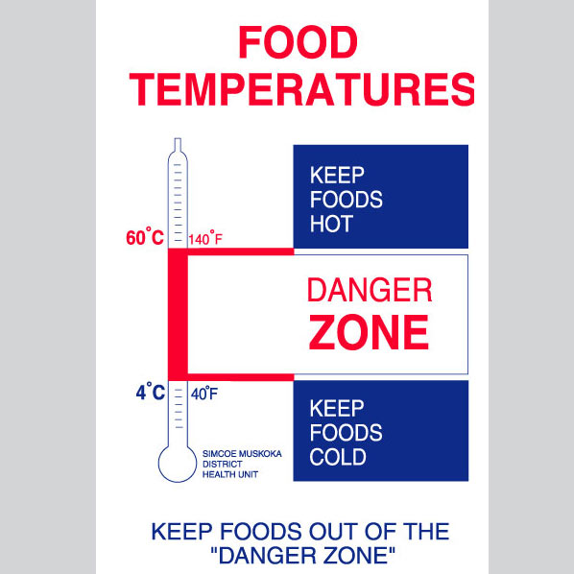

To control the spread and rapid growth of bacteria:
Remember to keep the temperature of ready to serve foods above 60 degrees Celsius or below 4 degrees Celsius until it is served.

Wash soiled equipment and food contact surfaces, as they may support the growth of bacteria.

The only way to stop the growth of bacteria is to use heat for an adequate amount of time at an adequate temperature. (Above 74 degrees Celsius.)

Common misconceptions:
- Freezing will not stop the growth of bacteria; it will only slow it down.
- Washing fruits and vegetables will not remove pesticides. It will only remove dirt.

- Potentially Hazardous Foods

Meat and Poultry
- Many animals and poultry carry pathogens like salmonella or E. coli in their gastrointestinal tract and feces. The raw meats are often contaminated during the slaughtering of the animals and during processing the meat.

Milk and Milk Products
- These are a good food source for infants, the elderly and the ill, who belong to a high risk group. Unpasteurized milk has been known to cause food borne outbreaks.

Eggs
- Food made with eggs such as hollandaise sauce, custards, cream cheese or salad has been known to cause food borne outbreaks.

Fish and Shellfish
- These are mainly high protein foods and are suitable as a food source for pathogens. They spoil rapidly and should always be stored well below the Danger Zone temperature.

Cooked Cereals and Vegetables
- These foods contain lots of moisture and allow the pathogens to use them as a food source. Examples: Rice, Oatmeal, Casseroles, Stir-fry.

- Contaminated versus Spoiled Foods
Ways to tell if your food is safe for you and those you serve.

Spoiled Foods:

You can tell your good has spoiled by
- Odour
- Taste
- Look

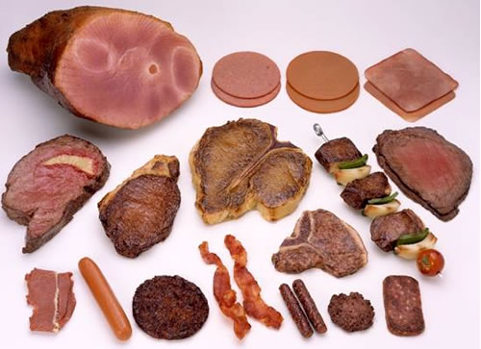

Why does food spoil?
It spoils for two reasons:
1) When air gets at it, it oxidizes and its quality diminishes.
2) Bacteria from the air land on the food and begin to grow, this causes an unpleasant smell, bad taste, and the food discolors and becomes dangerous to eat.

Food can also spoil due to the growth of microbes indigenous to the food. For example: Milk will spoil because pasteurization does not sterilize the milk. Eventually, the microbiological load will make the milk inedible.
Foods can also contain enzymes which will break down the structure. The ripening of fruit is related to enzymes.
Most foods spoil due to microbiological growth. Moulds, yeast and/or bacteria can sour food, change the appearance and texture and make the food generally unappetizing and undesirable.

How to stop food from spoilage:
- Preventing contamination
- Storing it properly
- Consuming it in a timely manner

Contaminated Foods:

- Food borne intoxication results from the consumption of food containing toxins.

- These occur when bacteria grow in food and give off a waste product called a toxin. (poison)

- The usual symptoms are nausea, vomiting, headache, dizziness and sometimes cramps. Symptoms occur between ½ to 5 hours after eating.

- These bacteria are found in noses, throats and ears of up to 50% of all people and on the hands of up to 20% of all people.

- The toxins are colourless, odourless and tasteless.

- Holding, Heating and Cooling
Proper techniques for safely heating and cooling foods.

Holding

  - Don’t add food
  - Ice must be made from drinkable water
  - Keep equipment clean
  - Wash containers
  - Do not place packed food directly on ice
  - Hold cold food below 4 degrees Celsius and hot food above 60 degrees Celsius
  - Stir food often

Reheating

- Only re-heat once to avoid food going through the danger zone too many times
- Re-heat to a minimum of 74 degrees Celsius
- Never add re-heated food to fresh food

Cooling

Large amounts of food take a long time to cool down; they may remain in the danger zone too long.

To Speed cooling:
- Use shallow pans for even cooling distribution times
- Place hot food in ice bath

Food must be cooled from 60 degrees Celsius down to 20 degrees Celsius with 2 hours, and from 20 degrees Celsius down to 4 degrees Celsius within 4 hours.

- Handling Eating Utensils
A food handler should always prevent the spread of infection through eating utensils by following simple rules:
- Do not touch the brim of cups and glasses
- Pick up cups, knives, forks and spoons by the handles
- Handle dishes with fingers underneath and thumb on the rim
- Rewash anything with signs of stains
- Do not stack filled dishes on top of one another
- Do not wipe utensils with clothes or towels
- Do not blow on plates or cups
- Rewash anything that has fallen on the floor
- Discard cracked or chipped glassware
- Always air dry

- Handling Eating Utensils

Properly maintain and use your refrigerator to get the most out of it.
- Defrost regularly
- Store good so air can regulate freely
- Check the temperature
- Keep it clean

How to properly refrigerate your food:
- Never allow food to cool to room temperature before chilling in a refrigerator
- Put food into the fridge quickly after removing it from heat
- Get food through the Danger Zone as quickly as possible
- Frozen perishable foods should be thawed in the fridge, microwave or placed directly into the oven for immediate cooking
- It is dangerous to air thaw food at room temperature
- Air cooling at room temperature is dangerous

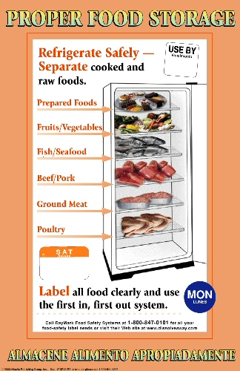
Use the FIFO Rule: First in first out.
Label all a leftovers with the date and use according to the FIFO rule.

- Quickly refrigerate custard desserts, creamed food, meats and pastries with perishable fillings to below 4 degrees Celsius if they are to be held before serving
- Cover all food and drink stored in the refrigerator
- Label all food and drink stored in the refrigerator
- Refrigerate foods in shallow layers to allow for rapid cooling
- Store fresh vegetables separately from other foods
- Never allow products that are ready to eat come in contact with raw products

- Proper Storage

Food can be contaminated, lose flavours and food value if proper storage conditions are not maintained.

Storage Rules:
- Areas should be dry, well ventilated and have adequate lighting
- Arrange shelves for easy cleaning
- All food should be covered
- Check daily for any food which have spoilage
- Store glasses and cups upside down on a clean dry surface
- Store dishes at least 2 ½ feet above the floor on clean shelves/cabinets
- Shelf liner should be used on old or hard to clean areas

- Bathroom and Laundry Standards
  - Shower/bath tub needs to be cleaned after every use
  - No communal bath mats: Each individual in the home needs to use a clean towel or mat that belongs to them
  - Each person in the home needs to have their own set of towels for both body and hands
  - Each persons laundry needs to be washed separately
  - Laundry needs to be folded in the laundry room or in the individual’s bed room
  - No food can be stored in the laundry room

- Cleanliness in home and kitchen

- Hand washing dishes- use the 3 sink method: soap & water, rinse, water & bleach
- Do not wash med. cups in the dishwasher. Single use only.
- Wash counters and tables at least once with sanitized wipe
- Wash high touch areas at least once daily with a sanitized wipe
- High touch areas include:
  - Light switches
  - Door knobs
  - Railings
  - telephone

